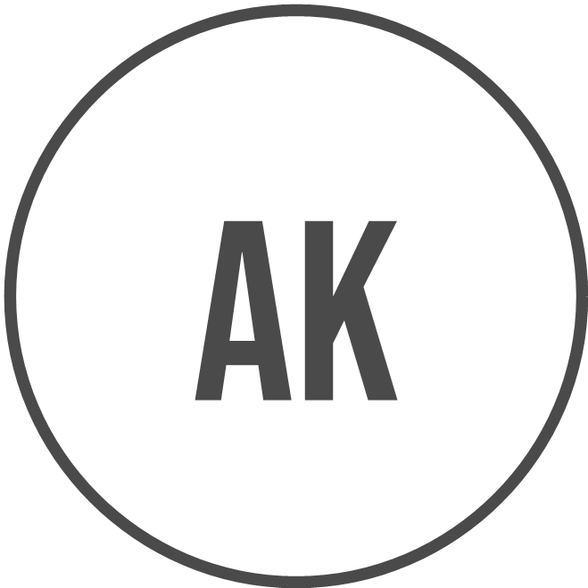
Ananya Kulkarni
Technical Writer
+91 98765 43210 | ananya.kulkarni@example.com | Pune, Maharashtra 411045
Date of Birth: 18 August 1998

Professional Summary

Technical Writer with extensive experience in creating comprehensive user guides, API documentation, and release notes for enterprise software solutions. Skilled in collaborating with cross-functional teams to ensure clarity and accuracy in technical documentation. Ready to leverage expertise in software documentation and stakeholder coordination to enhance documentation processes in the next role as a Technical Writer.

Experience

TechMahindra Ltd. | Pune, Maharashtra  Technical Writer  07/2023 - Present | - Developed user guides and online help documents for enterprise software used by banking and telecom clients.  - Collaborated with developers to translate complex technical features into simple and accurate end user documentation.  - Maintained version controlled documents using Git and ensured timely updates during every product release cycle.  - Created API documentation by reviewing Swagger files and coordinating with backend engineering teams regularly.  - Reviewed existing manuals to improve structure, clarity, and compliance with internal documentation standards.  - Participated in sprint meetings to understand feature changes and plan documentation timelines accordingly.  - Supported QA teams by documenting test scenarios, known issues, and product limitations clearly.

Infosys Ltd. | Bengaluru, Karnataka  Technical Writer  06/2021 - 06/2023 | - Prepared installation guides, configuration manuals, and troubleshooting documents for cloud based enterprise applications.  - Worked closely with solution architects to document system workflows and data flow diagrams accurately.  - Edited and standardized legacy documents to align with corporate style guides and terminology.  - Created release notes by consolidating inputs from development, testing, and product management teams.  - Managed document repositories and ensured proper naming, indexing, and version history maintenance.  - Conducted document reviews with SMEs to validate accuracy and completeness before client delivery.  - Assisted onboarding teams by creating internal knowledge base articles and quick reference guides.

Persistent Systems | Nagpur, Maharashtra  Junior Technical Writer  01/2019 - 05/2021 | - Created basic user guides and FAQs for web based software products under senior writer supervision.  - Converted developer notes into structured documentation suitable for non technical business users.  - Updated existing documents based on change requests received during maintenance and enhancement cycles.  - Followed documentation templates and style guidelines to maintain consistency across deliverables.  - Coordinated with QA teams to document known issues and workaround instructions clearly.  - Supported senior writers during large documentation projects by proofreading and formatting content.  - Learned documentation tools and processes while contributing to multiple client deliverables.

Education

10th Standard
St. Joseph's High School | Maharashtra
March 2013

12th Standard
Dr. Ambedkar Junior College | Maharashtra
March 2015

Bachelor of Engineering in Information Technology
Visvesvaraya National Institute of Technology | Maharashtra
May 2019

Skills

- Technical Documentation | - API Documentation
- User Manuals | - Release Notes
- Content Review | - Version Control
- Information Architecture | - Style Guides
- Software Documentation | - Stakeholder Coordination

Certifications

- Certified Technical Writer, IIT Bombay Spoken Tutorial | - API Documentation Certification, NASSCOM FutureSkills
- ISTQB Foundation Level Certification | - Technical Communication Certification, Symbiosis Centre for Distance Learning

Projects

Customer Portal Documentation, Created complete user and admin guides for a banking customer self service portal. API Reference Manual, Developed REST API documentation including endpoints, request formats, and response samples.

Industry

Information Technology and Software Services

Accomplishments

- Received client appreciation at TechMahindra Ltd. for improving documentation usability scores during audit review.
- Recognized at Infosys Ltd. for timely delivery of complete release documentation across multiple product versions.
- Awarded best junior contributor at Persistent Systems for documentation quality and accuracy.

References

References available upon request

